FOLK / ACOUSTIC / ROOTS SINGER SONGWRITER
ANNOUNCES THE RELEASE OF DEBUT ALBUM ‘CARONDELET’ ON 26th MARCH 2021
DEBUT SINGLE ‘BONNIE’ OUT NOW
Listen to the full Carondelet album here Watch the Bonnie Music Video Premiere here

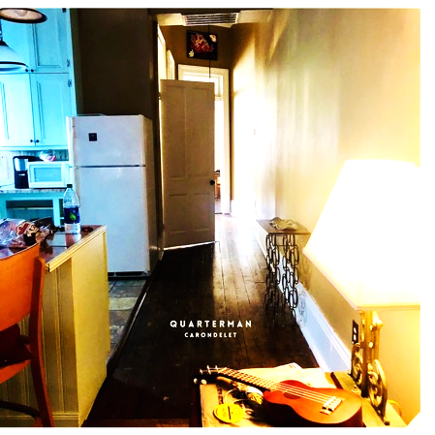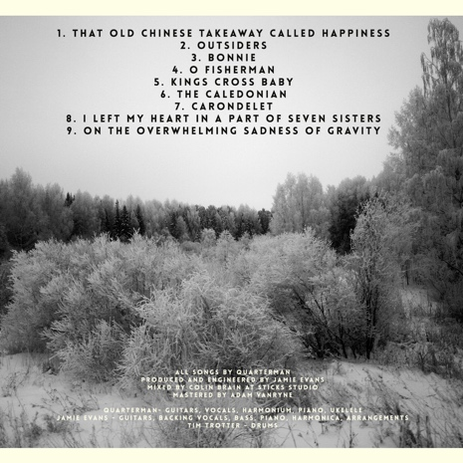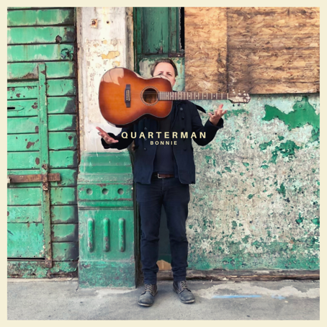

QUARTERMAN has announced details of the release of the debut album ‘CARONDELET’, on 26th March 2021. The album will be released on Quarterman’s own label, Wood Head Records.

QUARTERMAN is the name for the solo project of Man The Lifeboats’ lead singer and songwriter Richard James Quarterman. The album was recorded in the home studio of acclaimed producer Jamie Evans (Wildwood Kin, Lynne Jackaman, Antwerp Gipsy Ska Orkestra, Crawford Mack), mixed by Colin Brain at Sticks Studios and mastered by Adam Vanryne.

Sometime in the winter of 2018 Quarterman found himself with a collection of songs that were quieter and more introspective than the rest of the songs being bellowed across pubs, festival fields and venues with Man The Lifeboats. The songs drew inspiration from Neil Young, Simon & Garfunkel, Dylan, Waits, Richard Thompson, Nick Mulvey, Guy Garvey and Simon Armitage, and begged for a more delicate treatment.

The album came about after a brief search for a producer led to Quarterman getting back in touch with old school friend and musician Jamie Evans, after 20 years apart. The friends came back together to record the album in Jamie’s home studio, on the street that both grew up on. So behind the songs, there is the sound and the feeling of the reforging of a friendship, and the beginning of a musical journey.

CARONDELET features 9 original songs, featuring Quarterman’s acoustic guitar and vocals, and gritty and honest lyrics. The songs are a collection of tunes about love, loss, longing, from the streets of London, New Orleans, Dublin and Caledonia. Songs about lovers, underdogs, fishermen, and gaffer tape.

- That Old Chinese Takeaway Called Happiness  - Outsiders  - Bonnie (See Music Video)  - O Fisherman  - Kings Cross Baby  - The Caledonian  - Carondelet  - I Left My Heart In A Part Of Seven Sisters  - On The Overwhelming Sadness Of Gravity | Quarterman sings lead and backing vocals and plays acoustic and electric guitars, piano, harmonium and ukulele.
 | Jamie Evans sings backing vocals and plays lead acoustic and electric guitars, piano, ukulele, harmonica, bass, percussion, arrangements, strings, horns and effects.
 | Tim Trotter plays drums on ‘That Old Chinese Takeaway Called Happiness’ and ‘The Caledonian’.
Track By Track

- That Old Chinese Takeaway Called Happiness
Inspired by New Orleans, a long North London dog-walk, and the beginnings of a new relationship, this song came about on the drive home, when the feeling was mirrored and put into words by an actual Chinese Takeaway between Tottenham and Seven Sisters. One of those rare moments when the physical world and the realm of the senses somehow magically aligns.

- Outsiders
Outsiders is a quiet protest song, but one which carries an important sentiment, which has resonated for many years. When faced with suppression, anger, persecution, we so often respond with violence, anger or aggression. Maybe the most powerful retort instead is to respond with kindness. Jamie makes the ukulele here sound like an open desert plain.

- Bonnie (See Music Video)
Bonnie was written in the summer of 2016, on a cheap guitar, sitting on a porch in London, dreaming of hazy English meadows. It’s kind of a true story, combining the end of a few relationships and the longing to escape. Who is Bonnie? Is she the dog in the video? A lost lover? Someone or something else? Or all of the above?

- O Fisherman
O Fisherman was inspired by an Italian folk song, written and performed by the wonderful Lombardian folk band I’Luf. The song, O Pescator Che Peschi, sings of a fisherman sailing back to Sicily. When I first heard this, it was during the migrant crisis of 2015, and there were stories of Fisherman taking their boats and scrambling to save as many refugees as they could. This tragically still continues today.

- Kings Cross Baby
Written in 2005, this song disappeared for a decade. Over the years it has been a rock anthem, an indie epic, and in its latest form it is a fireside song, acoustic guitar accompanied by Jamie’s crackling fire, a few strings and piano chords, and a hurdy-gurdy. Jamie’s guitar solo in this is up there with the finest ever played, in this writer’s humble opinion anyway.

- The Caledonian
Originally written as a Man The Lifeboats folk anthem, the Caledonian found its home with Jamie’s swinging double bass line, and is one of the many on the album to feature ukulele. It’s about a fictional London pub, but the stories are all true. This pub is now sadly closed, like so many others. How we will miss them when they are gone.

- Carondelet
A pilgrimage to Bourbon Street, New Orleans, which, many years ago, was called Carondelet. The song was written on a ukulele, sitting on the porch of a shotgun shack in Tremé, listening to crickets and distant trains. Tropical heat, rainstorms over the bayou, jazz, blues, soul, whisky, gin, absinthe, it’s a special song about a special person and a very special time.

- I Left My Heart In A Part Of Seven Sisters
Another slow burner. Funny how some songs take minutes, others take years. Memories abound of living in a warehouse in Seven Sisters back in the noughties. There were a few parties, safe to say. It was the end of a time, the beginning of another, and a few things may have been left behind.

- On The Overwhelming Sadness Of Gravity
Long song titles, and indeed long songs, have always inspired. This is a ramble, a collection of thoughts, feelings, memories. All true. It came about after a trip to Dublin, and was recorded using a guitar from the 1940’s. Yes, that’s an orchestra tuning up in the background.

For more information on Quarterman’s releases, gigs, photos and bio please visit www.quartermanmusic.com
For more information about producer Jamie Evans visit www.jamieevansproducer.com
For more information and press enquiries contact info@quartermanmusic.com or call Rich on 07973 550136

